READING: The Five Consoles
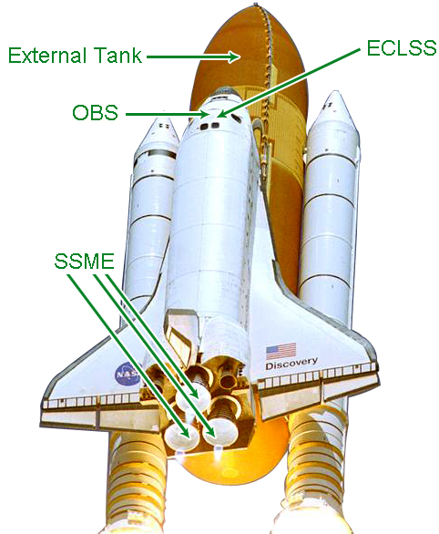

Weather Display
The KLASS Weather Display console is a simplified version of the Kennedy Space Center's Meteorological Interactive Data Display System known as MIDDS. MIDDS integrates diverse weather data on a single display, including weather radar and lightning strikes. This data helps forecasters determine if weather and lightning avoidance criteria are met.
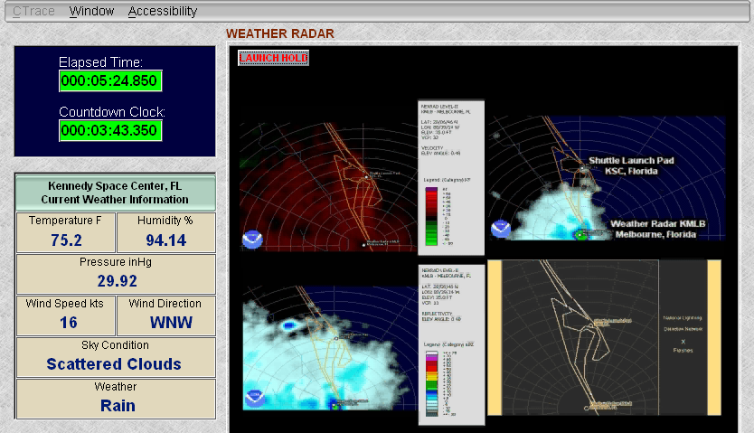

OBS (Operational Bio med Bioinstrumentation System)
The OBS console displays an electrocardiograph of two designated flight crewmembers. For these astronauts, it also displays pulse, respiration, oxygen level, blood pressure, and temperature.

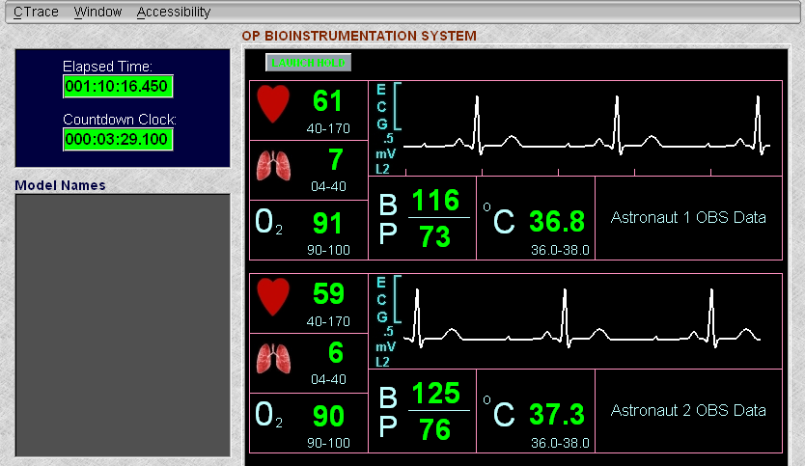

ECLSS (Environmental Control and Life Support System)
The ECLSS is responsible for maintaining a comfortable environment for the astronauts while they are out of their space suits and in the Orbiter's cabin. The graphic below display shows the part of the ECLSS responsible for maintaining a comfortable air temperature.

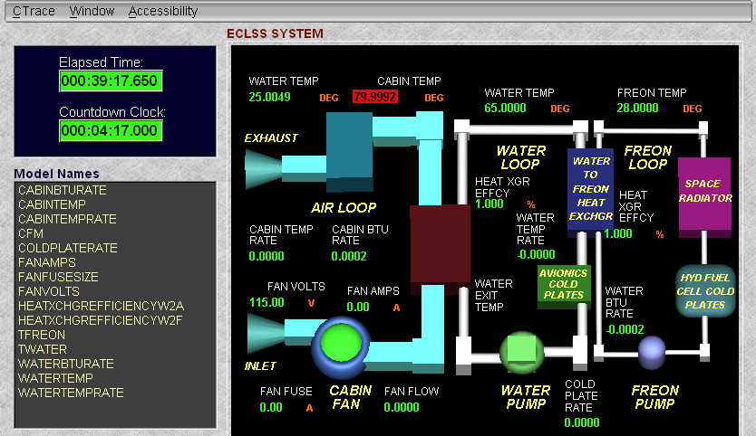

External Tank
The External Tank console monitors the flow of liquid oxygen and liquid hydrogen to the main engines.

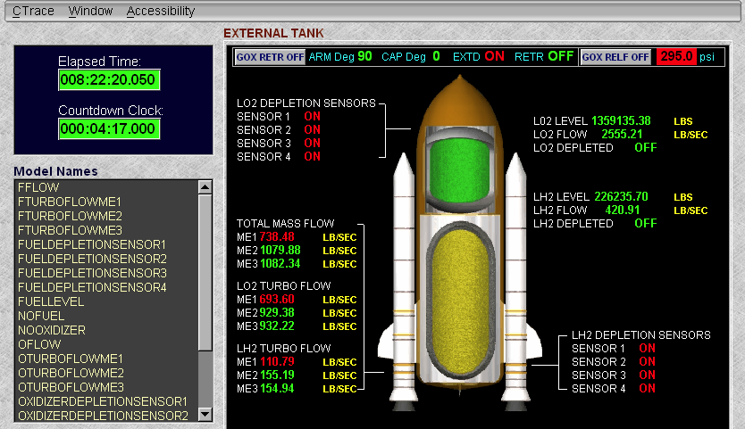

SSME (Space Shuttle Main Engine)
The SSME console monitors power output and propellant flow within the main engine. There are three SSME consoles, one for each of the Shuttle’s main engines. From each of these consoles, a Shuttle engineer can adjust fuel and oxidizer valves in order to produce the required amount of thrust for the Shuttle.
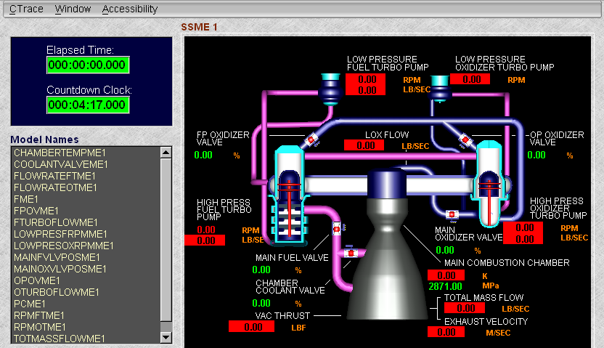

Console Components
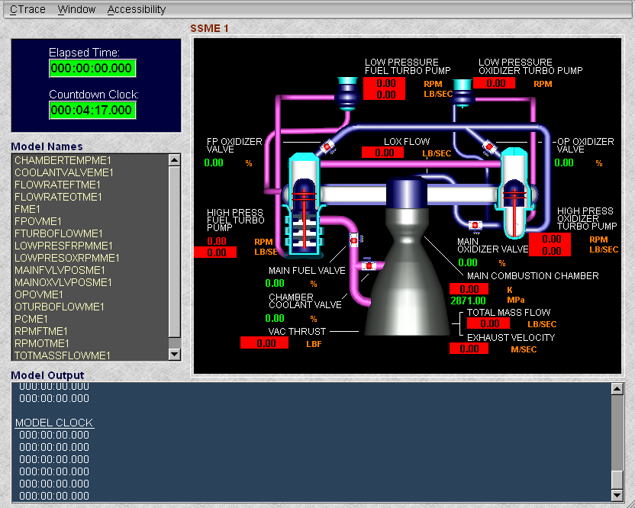
Timers

These “models”
may refer to value positions, sensor components, or computed values.
Model Output logs time or other events, depending on the console.
The Subsystem Schematic allows you to determine out-of-range values, which will be highlighted in red. When these values are brought into their target ranges, the highlighted areas will turn yellow briefly, and then green.

